

Week-1

1)Aim: To implement recursion in Python by creating a function that prints numbers in descending order from a given number.
Program:
def countdown(n):
print(n)
if n>0:
return countdown(n-1)
elif n==0:
return 0
n=int(input("Enter the number of counts:"))
countdown(n)
print("Launch!!!")
Output:
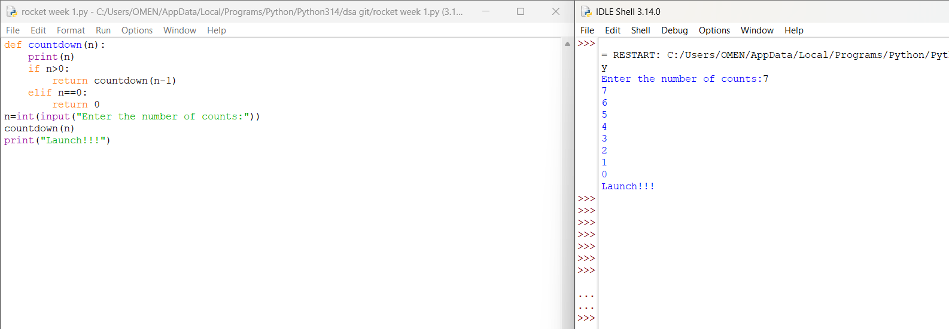
Explanation:
• The function launch(n) prints the current value of n.
• If n is greater than 0, it decreases n by 1 and calls itself recursively.
• The recursion continues until n becomes 0, which is the base case, and the function stops.

Error Table:
S.No | Error Obtained | Rectification
01. | Didn’t write the print statement after definition. | After execution I found the mistake and added it.

2)Aim: To implement a recursive binary search in Python to find the position (index) of a given element in a list. The program recursively checks each element of the list until the target element is found or the end of the list is reached.
Program:
def search_employee(ids, key, index=0):
if index == len(ids):
return -1
if ids[index] == key:
return index
return search_employee(ids, key, index + 1)

ids = list(map(int, input("Enter employee IDs: ").split()))
key = int(input("Enter employee ID to search: "))

result = search_employee(ids, key)

if result != -1:
print("Employee ID found at position", result + 1)
else:
print("Employee ID not found")
Output:
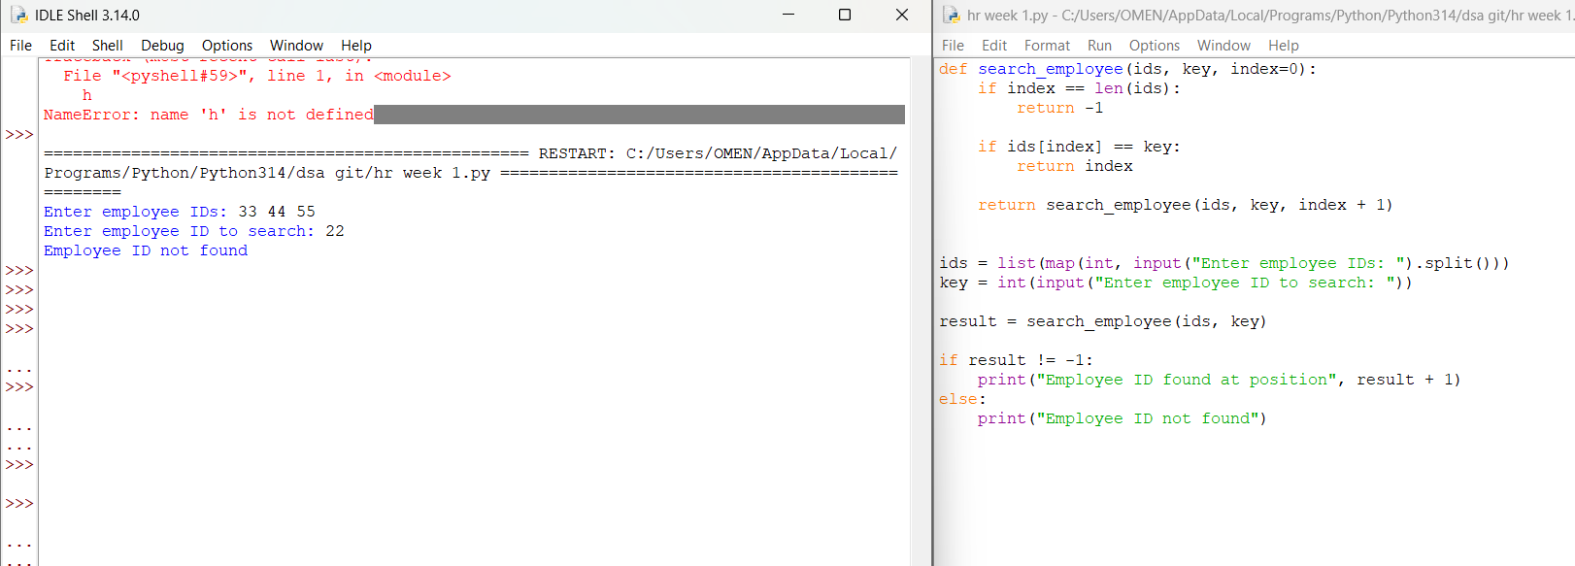

Explanation:
This program uses recursion to perform a linear search for an employee ID (or any target element) in a list.
- The function empid_Search(arr, target, n=0) is defined with three parameters:
  - arr: The list in which the search is performed.
  - target: The element to be searched.
  - n: The current index, initialized to 0.
- The statement if n == len(arr): return -1 is the base condition. It checks whether all elements in the list have been examined. If the end of the list is reached without finding the target, the function returns -1.
- The statement if arr[n] == target: return n compares the current element with the target. If they are equal, the function returns the current index where the target is found.
- If the current element does not match the target, the function calls itself recursively with the next index using return empid_Search(arr, target, n + 1).
- The list arr = [10, 20, 30, 50, 607, 809, 506] is created, and the function is called to search for the element 50.
- The returned value is stored in the variable result.
- If result is not equal to -1, the program prints the index where the element is found. Otherwise, it prints "Element not found."
Error table:
S.No | Error Obtained | Rectification
01. | Recursion Error: maximum recursion depth exceeded | Increment the index in the recursive call: return empid_Search(arr, target, n + 1).

3)Aim: This Python program uses recursion to calculate the value of pⁿ (p raised to the power n).
Program:
def power(p,n):
if n==0:
return 1
else:
return p*power(p,n-1)
p=int(input("Enter the value of p:"))
n=int(input("Enter the value of n:"))
result=power(p,n)
print(result)
Output:
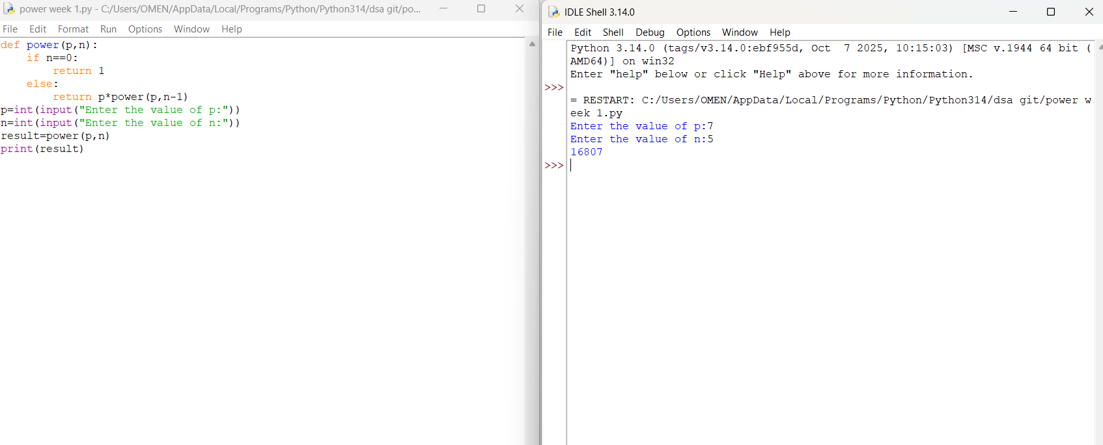

Explanation:
• The program is used to find the power of a number (pⁿ) using recursion.
• It takes two inputs from the user:
- p → Base number
- n → Exponent (power)
• The function power(p, n) is called to calculate the result.
• If the exponent n is 0, the function returns 1 because any number raised to the power 0 is
• If n is not 0, the function calls itself with n - 1 and multiplies the result by p.
• This recursive process continues until the exponent becomes 0.
• After reaching the base case, each recursive call returns its result, and the final value of pⁿ is obtained.
• The result is stored in the variable result.
• Finally, the program prints the calculated power of the given number.

Error Table:
S.No | Error Obtained | Rectification
01. | Not a int value of n we can also take float in place of int, I have taken float value to check. | By replacing int by float.

4)Aim: To write a Python program that generates and prints the Fibonacci series up to n terms using recursion.
Program:
def fib(n):
if n<=1:
return n
return fib(n-1) + fib(n-2)
n=int (input ("Enter the value of n:"))
print ("The fibanocci series:")
for i in range (n):
print(fib(i), end=" ")
Output: 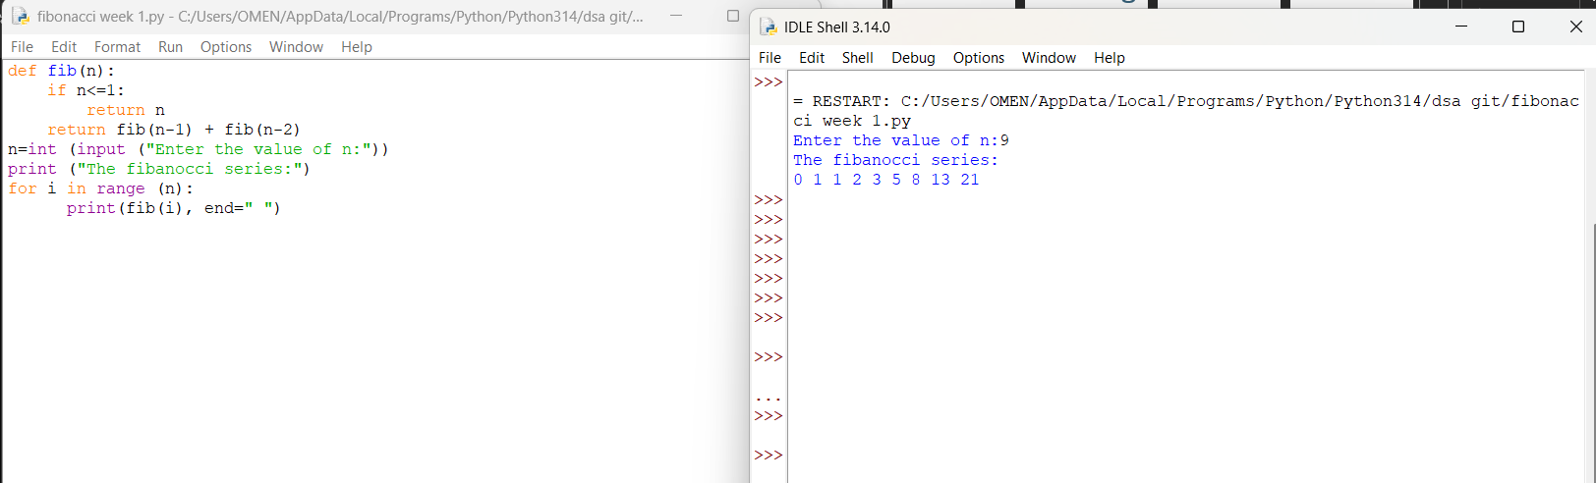

Explanation:
• The program uses a recursive function fib(n) to generate Fibonacci numbers.
• The base condition returns 0 when n = 0 and 1 when n = 1.
• For values greater than 1, the function returns the sum of the previous two Fibonacci numbers: fib(n-1) + fib(n-2).
• The user enters the number of terms (n) to be displayed.
• A for loop calls the fib() function repeatedly for each term from 0 to n-1.
• Finally, the program prints the Fibonacci series in sequence.
Error Table:
S.No | Error Obtained | Rectification
01. | No Errors obtained | -----------------------------------------

5)Aim: To write a Python program to find the factorial of a given number using recursion.
Program:
def factorial(n):
if n == 0 or n == 1:
return 1
return n * factorial(n - 1)

n = int(input("Enter a number: "))

if n < 0:
print("Factorial is not defined for negative numbers")
else:
print("Factorial of", n, "is", factorial(n))

Output:
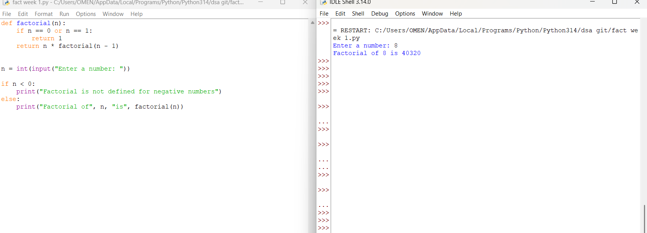

Explanation:
• The program defines a recursive function fact(n) to calculate the factorial of a number.
• The base condition checks if n <= 1. If true, it returns 1 (for factorial, 0! = 1 and 1! = 1).
• Otherwise, the function returns n * fact(n-1), multiplying the current number by the factorial of the previous number.
• The function is called with the value 6.
• Finally, the program prints the factorial of 6, which is 720.
Error Table:
S.No | Error Obtained | Rectification
01. | No Errors obatined | ---------------------------------------------------

Week-2
- Aim:- Write a program to perform linear search on the given input.
n = int(input("Enter number of elements: "))

a = list(map(int, input("Enter the elements: ").split()))

key = int(input("Enter the element to search: "))

found = False

for i in range(n):
if a[i] == key:
print("Element found at position", i + 1)
found = True
break

if not found:
print("Element not found")

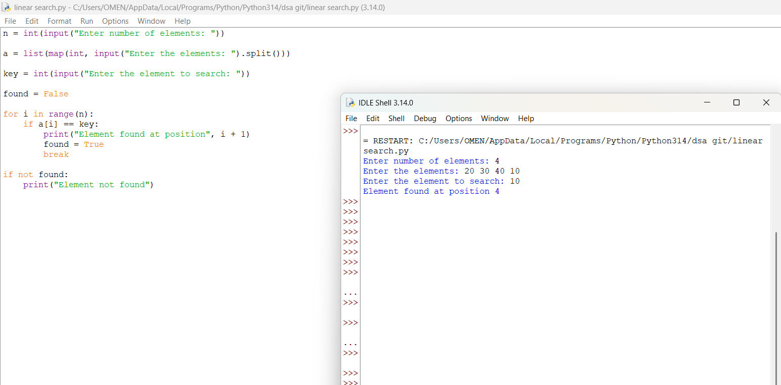

Linear search is a simple searching technique where each element of the list is checked one by one from the beginning until the required element is found.

The program:
- Reads the number of elements.
- Reads the list of elements.
- Reads the element to be searched (key).
- Compares key with each element using a for loop.
- If found, it displays the position.
- If no match is found, it displays "Element not found".

Error Table
S.No | Error Obtained | Rectification
1 | ValueError: invalid literal for int() | Enter only integer values when using int() or map(int, ...).
2 | IndexError: list index out of range | Make sure the number of elements entered matches the list size.
3 | Element position displayed incorrectly | Use i + 1 because Python list indexing starts from 0, while positions normally start from 1.
4 | "Element not found" displayed even when the element exists | Check that the comparison is written correctly as if a[i] == key:.
5 | Program continues searching after finding the element | Use break after finding the element.
6 | NameError for key | Make sure key is assigned using key = int(input(...)) before the search loop.
7 | Incorrect input format for multiple elements | Use list(map(int, input().split())) to read space-separated integers.

2)Aim:-Write a python program to perform binary search on the given input verify by taking sorted array and unsorted array as a input:-
Program:-
def binary_search(a, key):
low = 0
high = len(a) - 1

while low <= high:
mid = (low + high) // 2

if a[mid] == key:
return mid
elif a[mid] < key:
low = mid + 1
else:
high = mid - 1

return -1

a = list(map(int, input("Enter the elements: ").split()))
key = int(input("Enter the element to search: "))

if a == sorted(a):
result = binary_search(a, key)

if result != -1:
print("Element found at position", result + 1)
else:
print("Element not found")
else:
print("Array is unsorted. Binary search cannot be performed.")
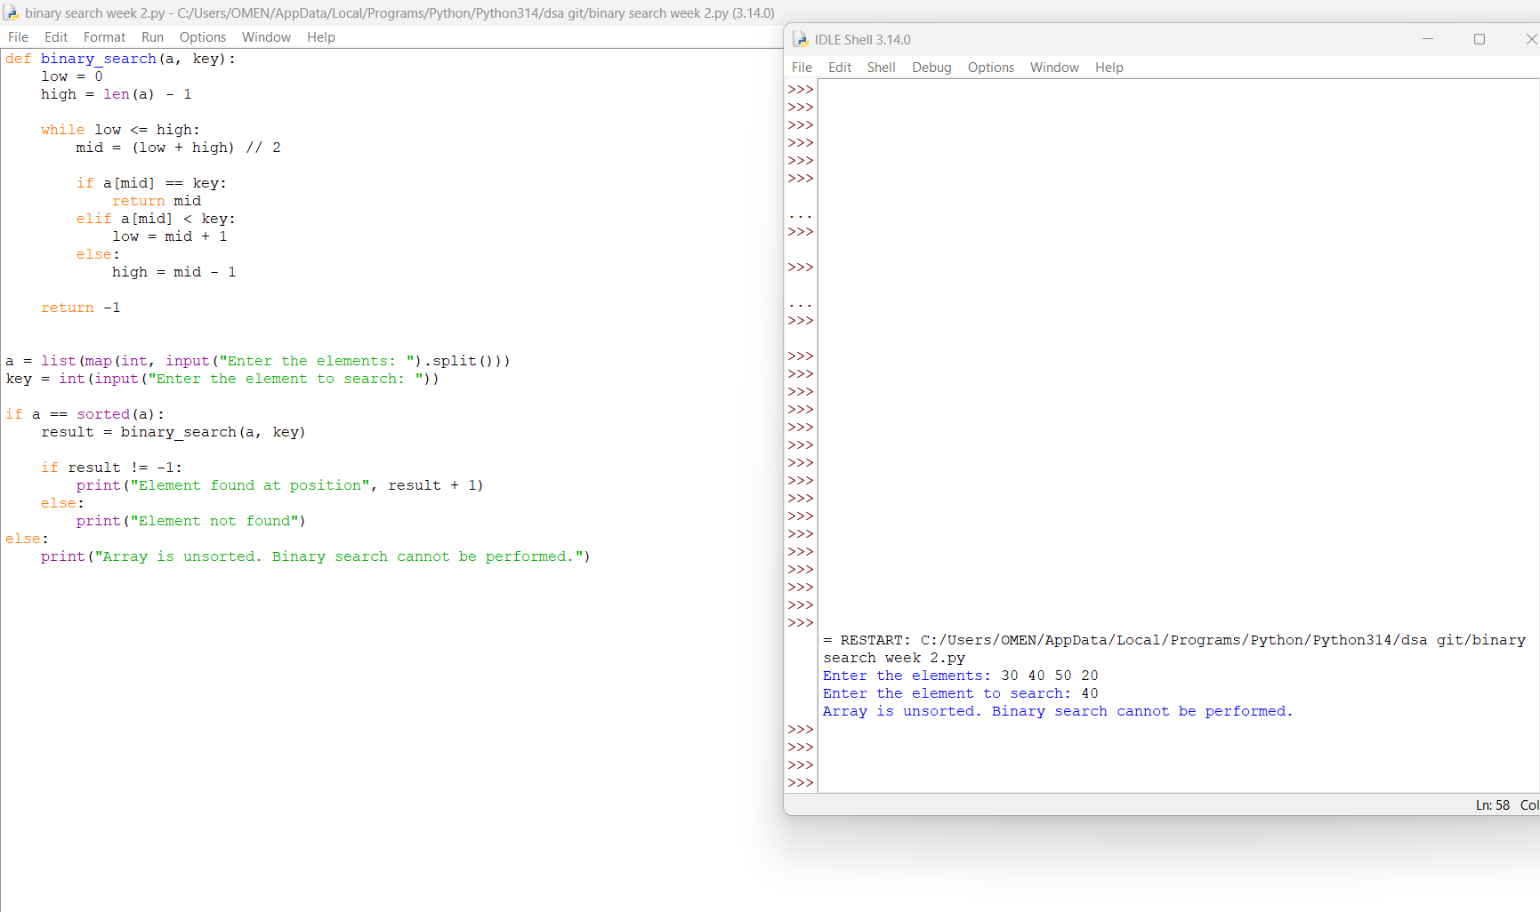
Binary Search works by repeatedly dividing a sorted array into two halves.
- low represents the starting index.
- high represents the ending index.
- mid represents the middle element.
- If a[mid] == key, the element is found.
- If a[mid] < key, search the right half.
- If a[mid] > key, search the left half.
- If the array is unsorted, binary search should not be performed.

Error Table
S.No | Error Obtained | Rectification
1 | ValueError while entering elements | Enter only integer values separated by spaces.
2 | Element not found even though it exists | Make sure the array is sorted before performing binary search.
3 | Wrong middle element | Use mid = (low + high) // 2.
4 | Infinite loop occurs | Update low or high after every comparison.
5 | Position is incorrect | Use result + 1 because Python indexing starts from 0.
6 | Binary search gives incorrect result for an unsorted array | Check whether the array is sorted before searching.

Week-3
3a)Aim:- Write a Python program to perform Bubble Sort on a given list of elements.
Program:-

n = int(input("Enter number of elements: "))
arr = []

for i in range(n):
arr.append(int(input("Enter element: ")))

for i in range(n - 1):
for j in range(n - 1 - i):
if arr[j] > arr[j + 1]:
arr[j], arr[j + 1] = arr[j + 1], arr[j]

print("Sorted list:", arr)

OUTPUT:-
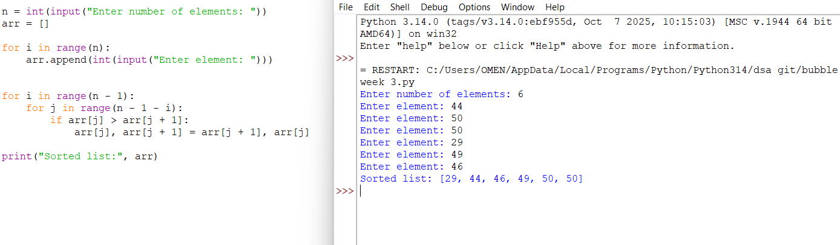
Explanation:
This program uses the Bubble Sort technique to sort elements in a list.
- The function bubble_sort(arr) is defined to sort the given list arr.
- The variable n = len(arr) stores the number of elements in the list.
- A loop runs from i = 0 to n-1, representing each pass of the sorting process.
- A variable swapped is initialized as False at the beginning of each pass.
  - It is used to check whether any swapping occurred during the pass.
- Another loop runs from j = 0 to n-i-2, comparing adjacent elements.
- The condition if arr[j] > arr[j + 1]: checks if the current element is greater than the next element.
  - If true, the elements are swapped using arr[j], arr[j + 1] = arr[j + 1], arr[j].
  - The variable swapped is set to True.
- After each pass, if no swapping occurs (swapped == False), the loop breaks early.
  - This indicates that the list is already sorted.
- The function returns the sorted list.
- The user inputs elements into the list a until "stop" is entered.
- The original list is printed, followed by the sorted list after calling bubble_sort(a).

Error Table – Bubble Sort Program
S.No. | Error | Reason | Correction
1 | ValueError: invalid literal for int() | Multiple values 44 55 66 70 were entered when the program expected only one integer for the number of elements. | Enter 4 as the number of elements, then enter each element separately.
2 | Incorrect input format | The program uses int(input()), which can convert only a single numeric value at a time. | Enter elements one by one, or modify the program to accept space-separated values.
3 | Program stops before sorting | The error occurs while reading input, so the Bubble Sort section is never executed. | Provide the input in the correct format.

3b)Write a Python program to perform Insertion Sort on a given list of elements.
Program:-
arr = list(map(int, input("Enter elements separated by spaces: ").split()))

n = len(arr)

for i in range(1, n):
key = arr[i]
j = i - 1

while j >= 0 and arr[j] > key:
arr[j + 1] = arr[j]
j = j - 1
arr[j + 1] = key
print("Sorted list:", arr)
Output:-
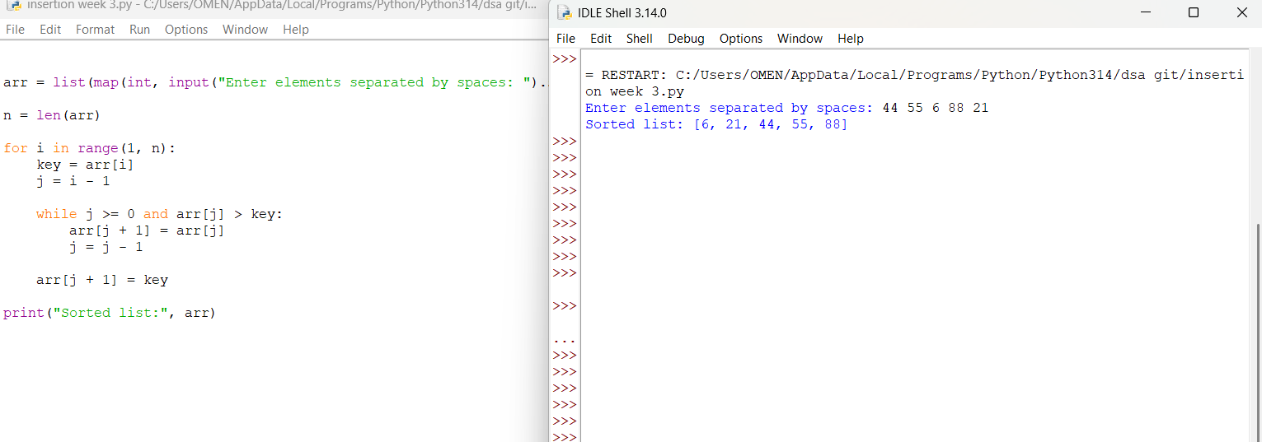
Explanation of the Insertion Sort Code
arr = list(map(int, input("Enter elements separated by spaces: ").split()))
- Takes multiple elements from the user in one line.
- split() separates the values by spaces.
- map(int, ...) converts them into integers.
- list() stores them as a list.
n = len(arr)
- Finds the number of elements in the list.
for i in range(1, n):
- Starts sorting from the second element because the first element is considered already sorted.
key = arr[i]
j = i - 1
- key stores the current element that needs to be placed correctly.
- j points to the element just before key.
while j >= 0 and arr[j] > key:
- Compares the key with the previous elements.
- If the previous element is larger, it needs to be shifted to the right.
arr[j + 1] = arr[j]
j = j - 1
- Moves the larger element one position to the right.
- Then checks the next element on the left.
arr[j + 1] = key
- Places the key in its correct position.
print("Sorted list:", arr)
- Displays the final sorted list.
Error Table
S.No. | Error | Reason | Correction
1 | ValueError: invalid literal for int() | Non-numeric values were entered. | Enter only numbers.
2 | IndexError: list index out of range | An invalid list index was accessed. | Check the loop range and index values.
3 | IndentationError | Spaces/tabs are not properly aligned. | Maintain proper indentation inside for and while blocks.
4 | SyntaxError | A Python statement is written incorrectly. | Check brackets, colons, and spelling.
5 | Wrong sorting output | The shifting or insertion logic was written incorrectly. | Check arr[j + 1] = arr[j] and arr[j + 1] = key.

3c)Aim:-
Write a Python program to perform Selection Sort on a given list of elements.
Program:-
def selection_sort(arr):
n = len(arr)
for i in range(n):
min_idx = i
for j in range(i + 1, n):
if arr[j] < arr[min_idx]:
min_idx = j
arr[i], arr[min_idx] = arr[min_idx], arr[i]
return arr
a = []
while True:
elem = input("Enter an element (or enter stop to finish):- ")
if elem.lower() == "stop":
break
a.append(int(elem))
print("Original List:", a)
sorted_list = selection_sort(a)
print("Sorted List: ", sorted_list)
Output:- 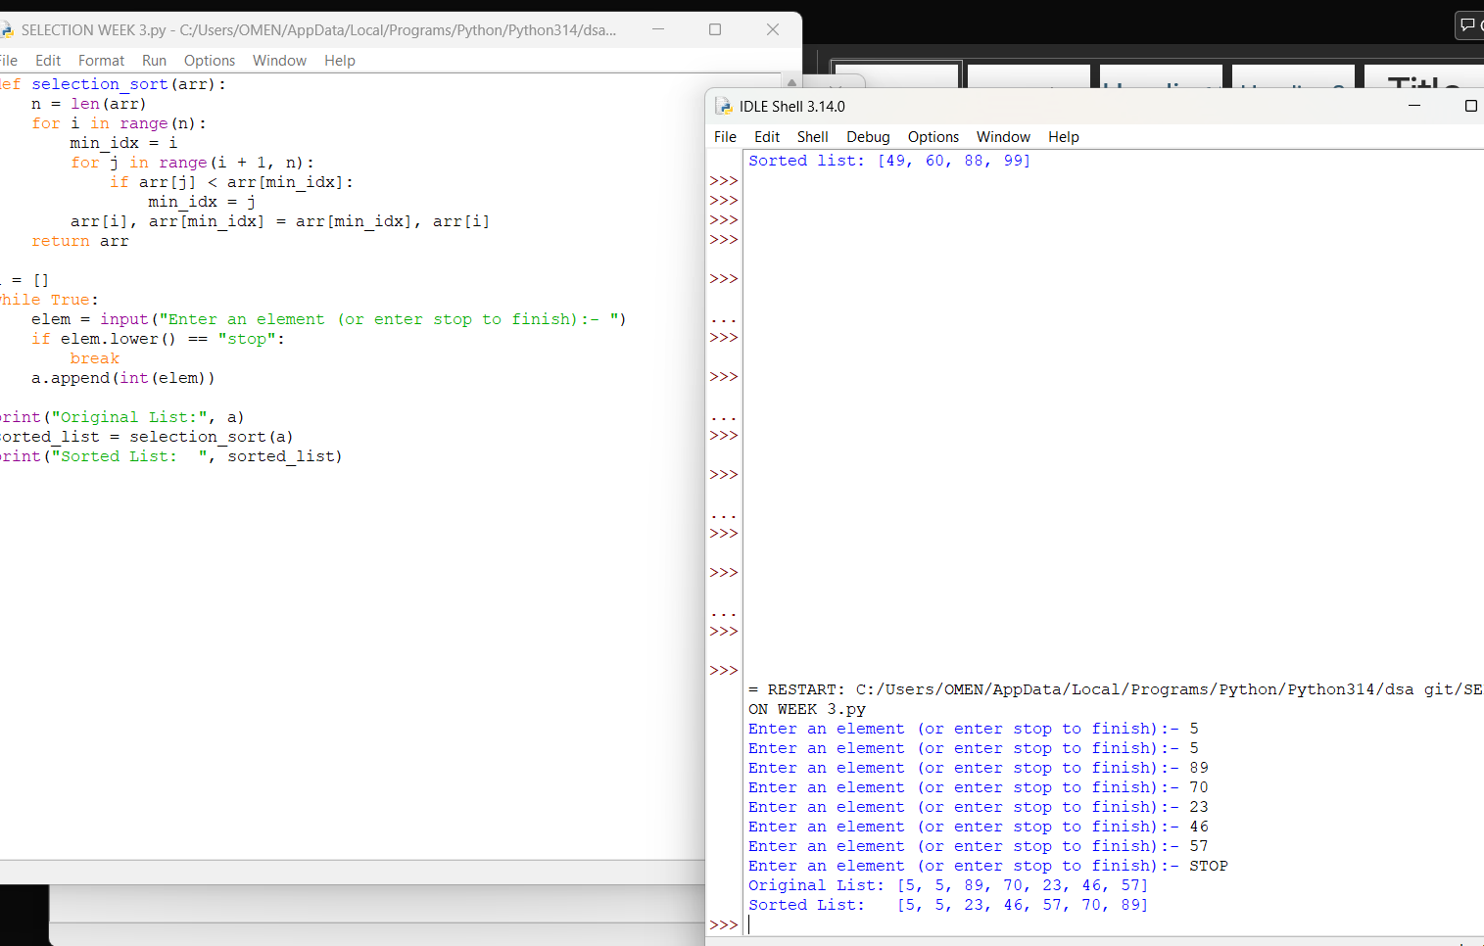

Explanation:
This program uses the Selection Sort technique to sort elements in a list.
- The function selection_sort(arr) is defined to sort the given list arr.
- The variable n = len(arr) stores the number of elements in the list.
- A loop runs from i = 0 to n-1, representing the position where the smallest element should be placed.
- The variable min_idx = i is initialized to store the index of the minimum element in the unsorted portion.
- Another loop runs from j = i + 1 to n-1, comparing elements in the unsorted part of the list.
- The condition if arr[j] < arr[min_idx]: checks if a smaller element is found.
  - If true, min_idx is updated with the index of that smaller element.
- After finding the smallest element, it is swapped with the element at position i using
arr[i], arr[min_idx] = arr[min_idx], arr[i].
- This process continues until the entire list is sorted.
- The function returns the sorted list.
- The user inputs elements into the list a until "stop" is entered.
- The original list is printed, followed by the sorted list after calling selection_sort(a).

Error Table:
S.No | Error Obtained | Rectification
01. | ValueError when non-integer input is entered | Ensure input is integer or handle using try-except
02. | Program fails for empty list | Check if list is empty before sorting
03. | Sorting modifies original list | Use a copy of list if original order must be preserved
04. | Incorrect sorting if comparison condition is wrong (arr[j] > arr[min_idx]) | Ensure correct condition arr[j] < arr[min_idx] is used

3d)Write a Python program to perform Merge Sort on a given list of elements.
Program:-
# Merge Sort Program

def merge_sort(arr):
if len(arr) <= 1:
return arr

mid = len(arr) // 2

left = merge_sort(arr[:mid])
right = merge_sort(arr[mid:])

result = []
i = 0
j = 0

while i < len(left) and j < len(right):
if left[i] <= right[j]:
result.append(left[i])
i += 1
else:
result.append(right[j])
j += 1

result.extend(left[i:])
result.extend(right[j:])

return result

arr = list(map(int, input("Enter elements separated by spaces: ").split()))

arr = merge_sort(arr)

print("Sorted list:", arr)
Output:-
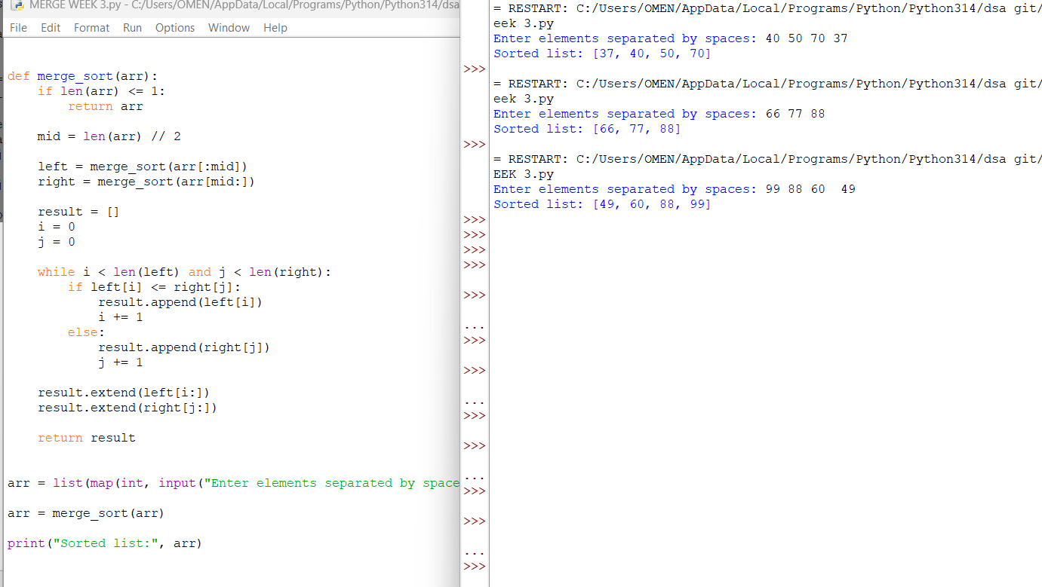
Explanation:
This program uses the Merge Sort technique to sort elements in a list using recursion.
- The function merge_sort(arr) is defined to sort the given list arr.
- The condition if len(arr) > 1: checks whether the list has more than one element.
  - If not, the list is already sorted (base case).
- The list is divided into two halves:
  - mid = len(arr) // 2 finds the middle index.
  - L = arr[:mid] stores the left half.
  - R = arr[mid:] stores the right half.
- The function recursively calls itself on both halves using merge_sort(L) and merge_sort(R).
- Three variables i, j, and k are initialized to 0:
  - i → index for left sublist
  - j → index for right sublist
  - k → index for merged list
- A while loop compares elements of L and R:
  - The smaller element is placed into arr[k].
  - Corresponding indices are incremented.
- After one sublist is exhausted, remaining elements of the other sublist are copied using two separate while loops.
- The sorted elements are merged back into the original list arr.
- The function returns the sorted list.
- The user inputs elements into the list a until "stop" is entered.
- The original list is printed, followed by the sorted list after calling merge_sort(a).
Error Table:
S.No | Error Obtained | Rectification
01. | ValueError when non-integer input is entered | Ensure input is integer or handle using try-except
02. | Program fails for empty list | Check if list is empty before sorting
03. | Incorrect merging if indices (i, j, k) are not updated properly | Ensure all indices are incremented correctly
04. | High memory usage due to creating sublists (L and R) | Use optimized in-place merge sort if required

3e) Write a Python program to perform Quick Sort on a given list of elements.
Program:-

def quick_sort(arr):
if len(arr) <= 1:
return arr

pivot = arr[-1]
left = []
right = []

for i in arr[:-1]:
if i <= pivot:
left.append(i)
else:
right.append(i)

return quick_sort(left) + [pivot] + quick_sort(right)

arr = list(map(int, input("Enter elements separated by spaces: ").split()))

arr = quick_sort(arr)

print("Sorted list:", arr)
Output:-
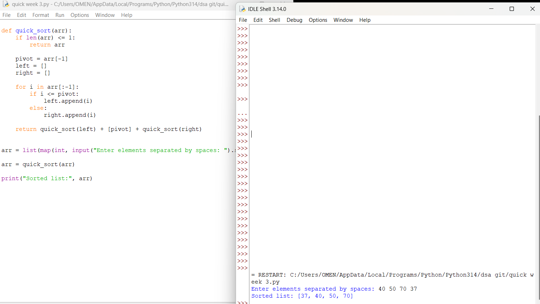

Explanation:
This program uses the Quick Sort technique to sort elements in a list using recursion.
- The function quick_sort(arr, low=0, high=None) is defined with parameters:
  - arr: The list to be sorted
  - low: Starting index (default 0)
  - high: Ending index (default last index of list)
- If high is None, it is initialized as len(arr) - 1.
- The condition if low < high: ensures that sorting is performed only when there are at least two elements.
- The last element arr[high] is chosen as the pivot.
- The variable i = low - 1 is used to track the position of smaller elements.
- A loop runs from j = low to high - 1:
  - If arr[j] <= pivot, i is incremented and elements are swapped using
arr[i], arr[j] = arr[j], arr[i].
- After the loop, the pivot is placed at its correct position using
arr[i + 1], arr[high] = arr[high], arr[i + 1].
- The pivot index pi = i + 1 divides the array into two parts.
- The function recursively sorts:
  - Left subarray → quick_sort(arr, low, pi - 1)
  - Right subarray → quick_sort(arr, pi + 1, high)
- The function returns the sorted list.
- The user inputs elements into list a until "stop" is entered.
- The original list and sorted list are printed.

Error Table:
S.No | Error Obtained | Rectification
01. | ValueError when non-integer input is entered | Ensure input is integer or handle using try-except
02. | Program fails for empty list | Check if list is empty before sorting
03. | Worst-case performance (O(n²)) for already sorted list | Use better pivot selection (e.g., middle or random pivot)
04. | Recursion depth error for very large lists | Increase recursion limit or use iterative approach

